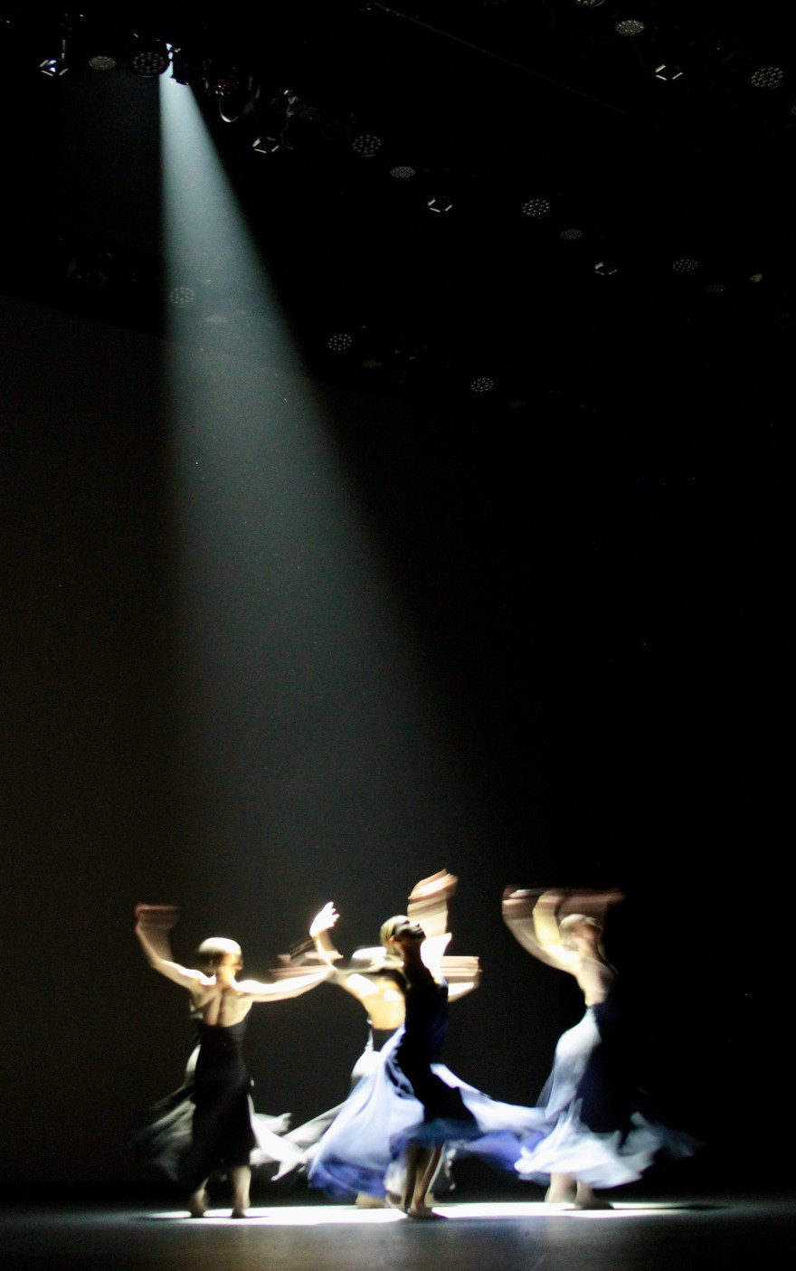

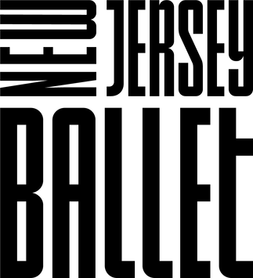

ASSISTANT DIRECTOR
Paul H. McRae
ARTISTIC DIRECTOR
Maria Kowroski

EXECUTIVE DIRECTOR
David Tamaki

ARTISTIC COORDINATOR
Kotoe Kojima-Noa

PRODUCTION MANAGER
Brian Coakley
SCHOOL ADMINISTRATOR
Toni Ann Auriemma

WARDROBE MANAGER
Peggy Casey

LIGHTING SUPERVISORS
Jesse Campbell, Lauren Libretti
PRODUCTION STAGE MANAGER
Mary Kate Grimes

REPERTORY COACHES
Rosemary Sabovick-Bleich Kotoe Kojima-Noa, Zoe Zien

THE COMPANY
Emily Barrows, Louis DeFelice, Vinicius Freire, Yuiko Honda Akira Iida, Se Hyun Jin, Ilse Kapteyn, Raleigh Ledford
David Lopena, Risa Mochizuki, Denise Parungao, Jonathan Philbert Abigail Robison, George Sanders, Brian Sevilla, Eunice Suba
Felipe Valentini, Joshuan Vazquez, Catherine Whiting
Lilli Etheredge, Alexandra Limeburg

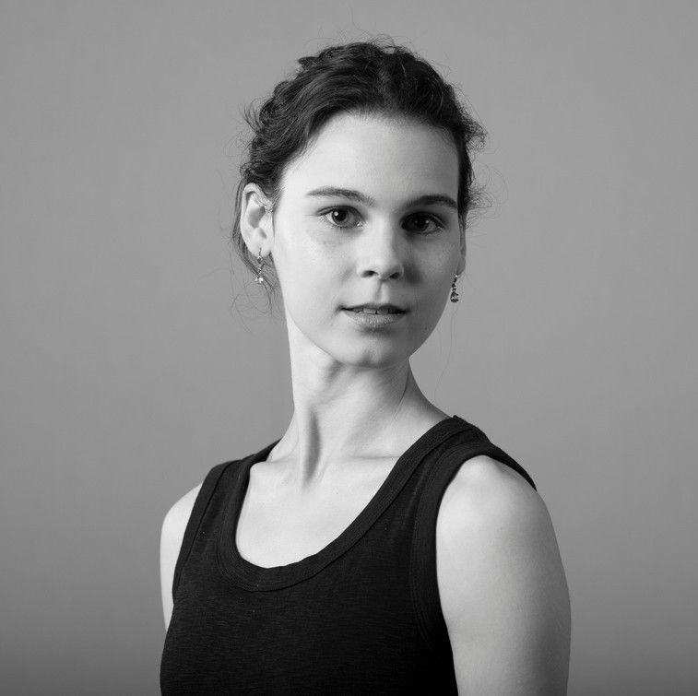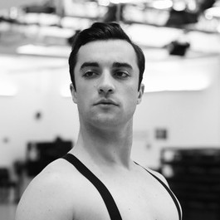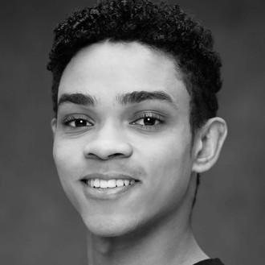
EMILY BARROWS LOUIS DEFELICE VINICIUS FREIRE

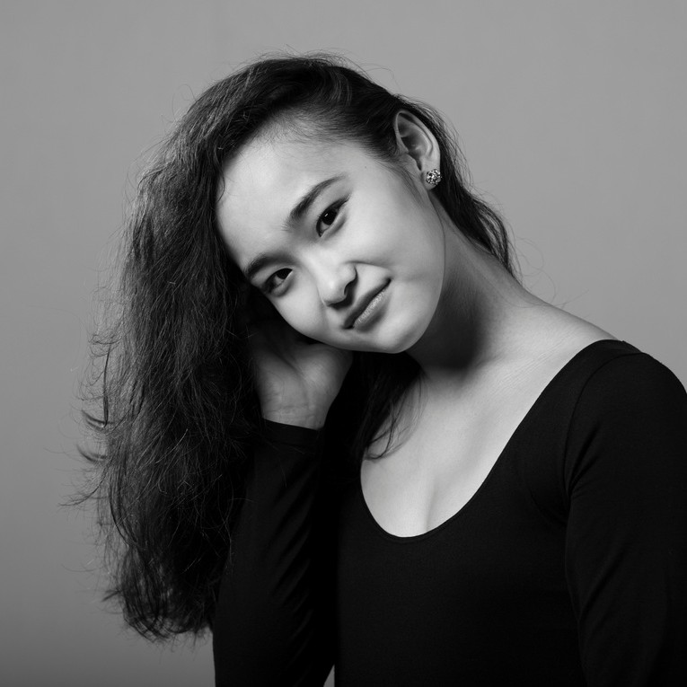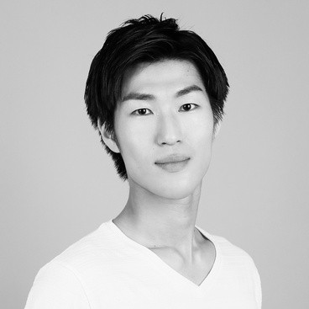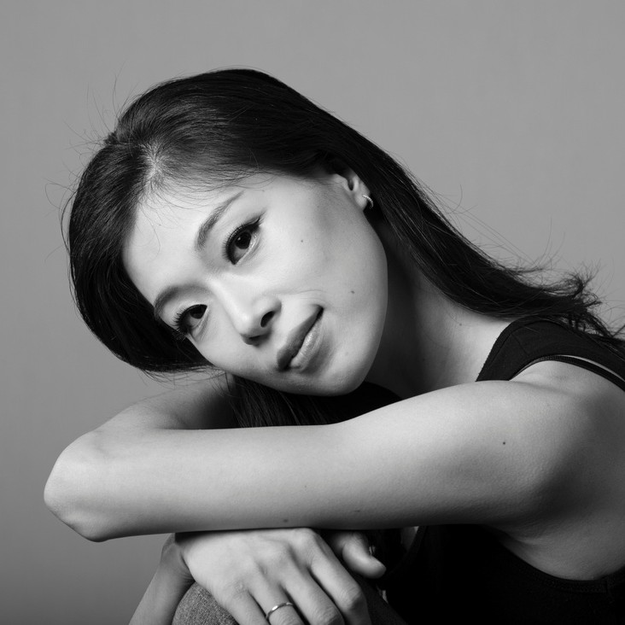

YUIKO HONDA
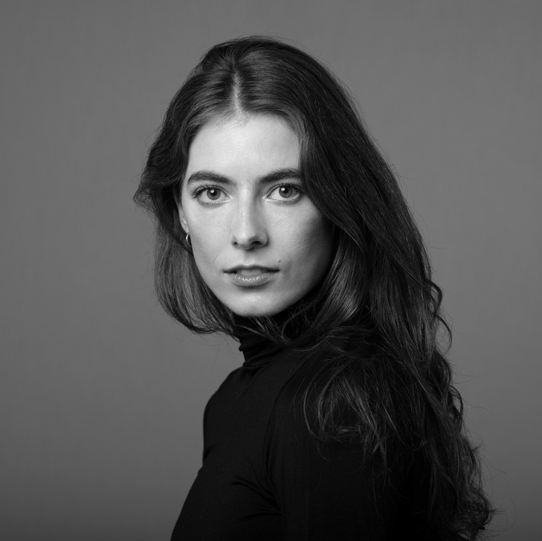
ILSE KAPTEYN
AKIRA IIDA

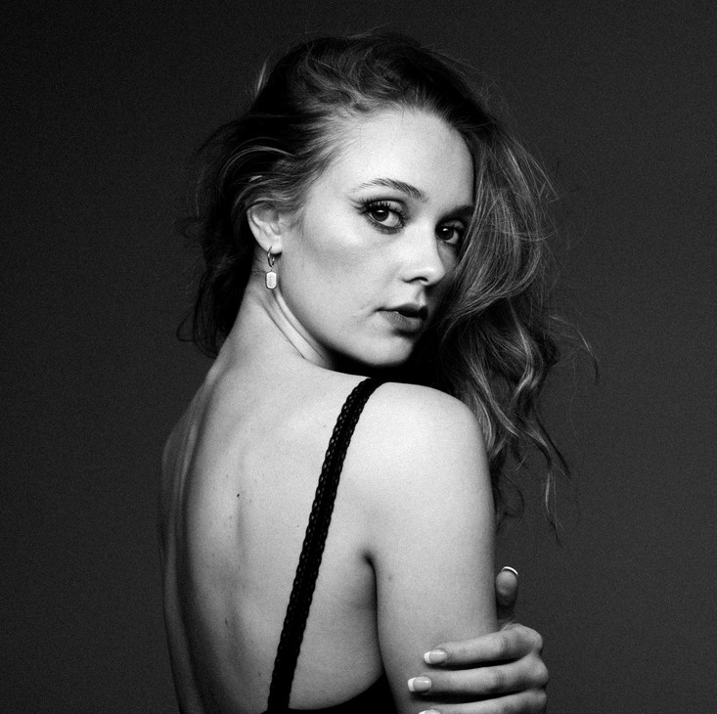
RALEIGH LEDFORD
SE HYUN JIN
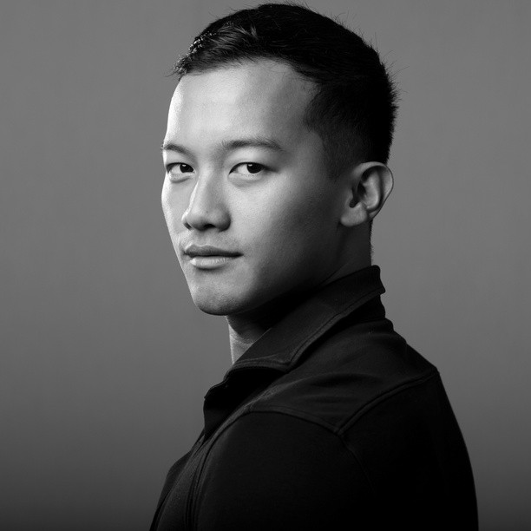
DAVID LOPENA

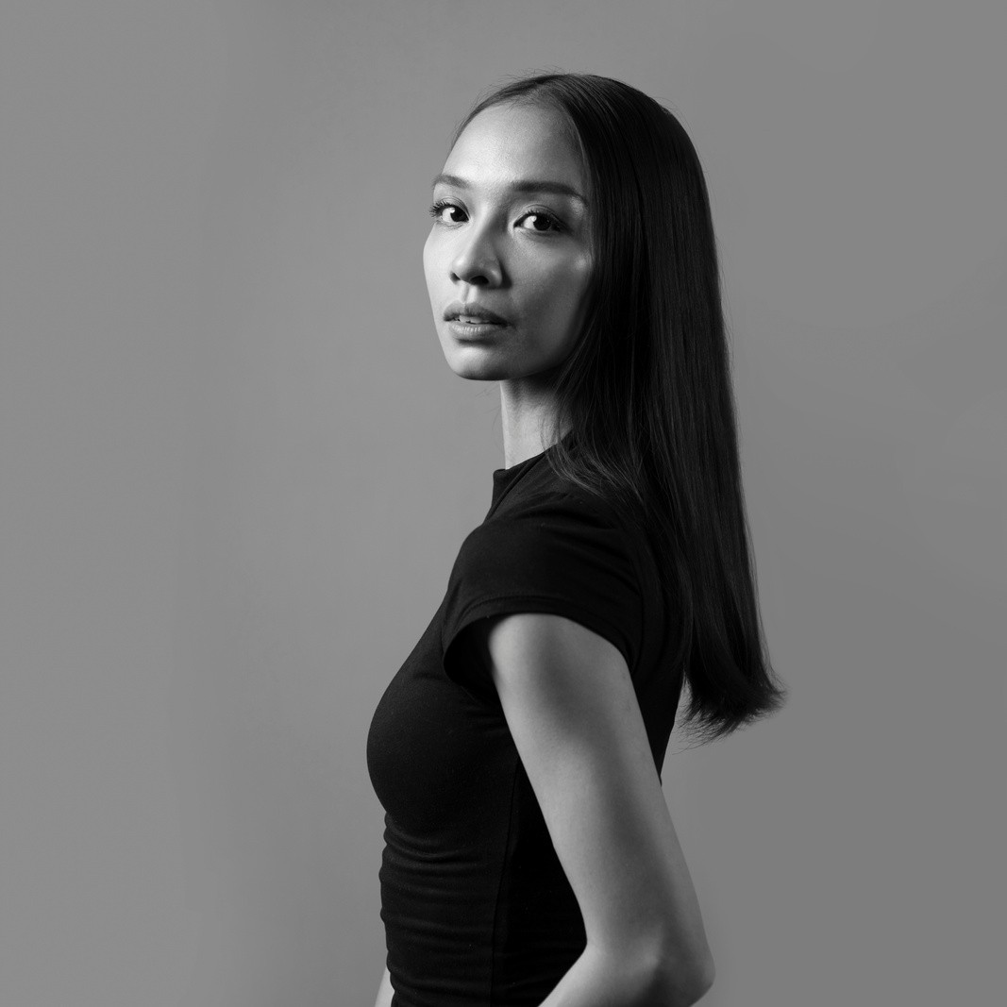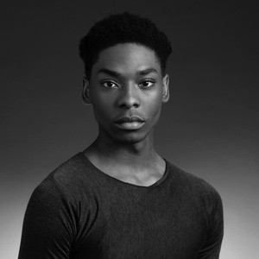
RISA MOCHIZUKI DENISE PARUNGAO JONATHAN PHILBERT

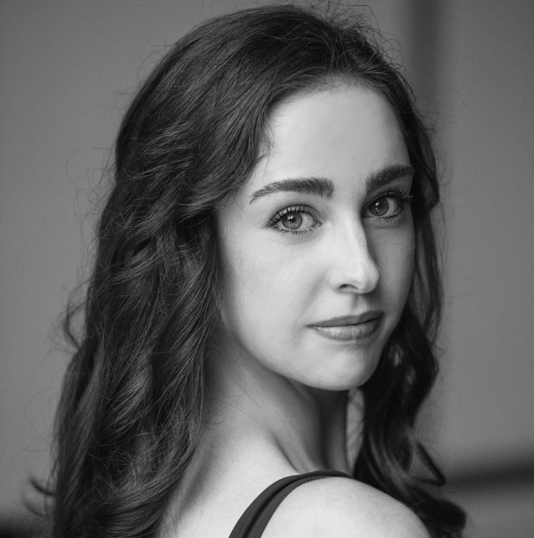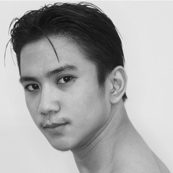
ABIGAIL ROBISON GEORGE SANDERS BRIAN SEVILLA
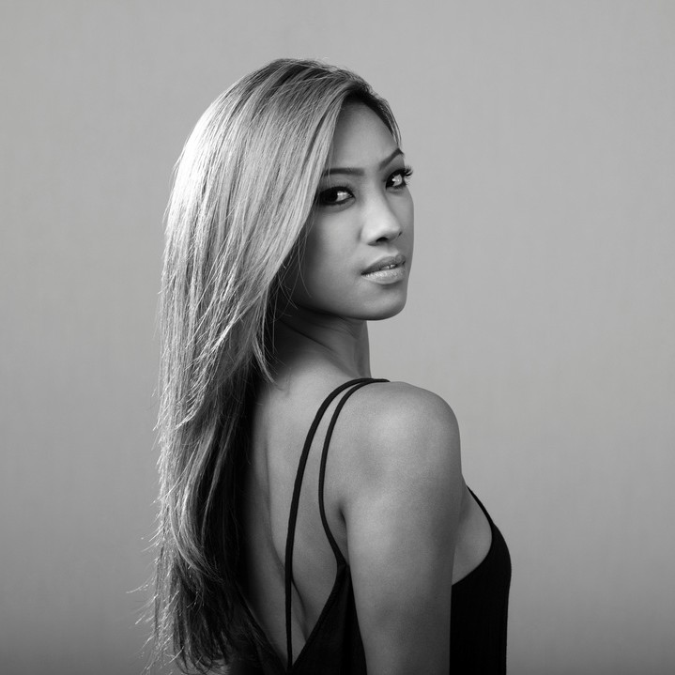
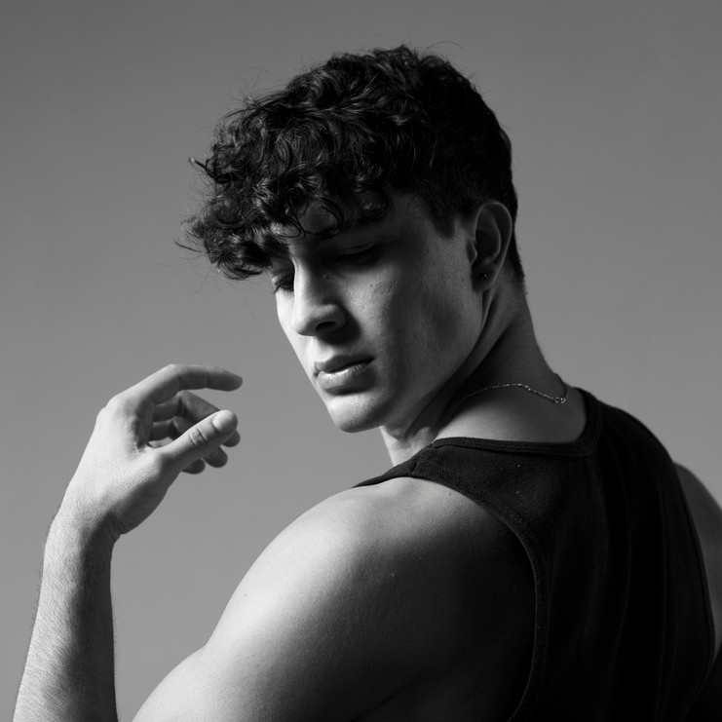
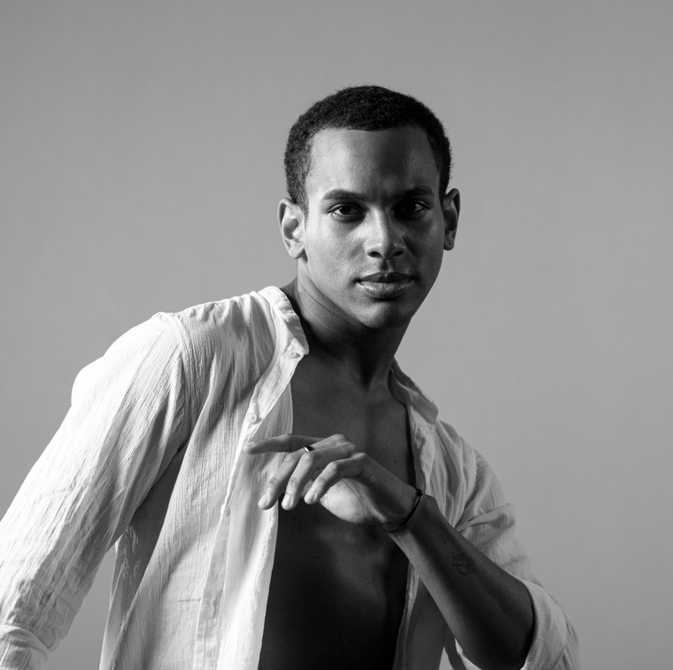
EUNICE SUBA FELIPE VALENTINI JOSHUAN VAZQUEZ
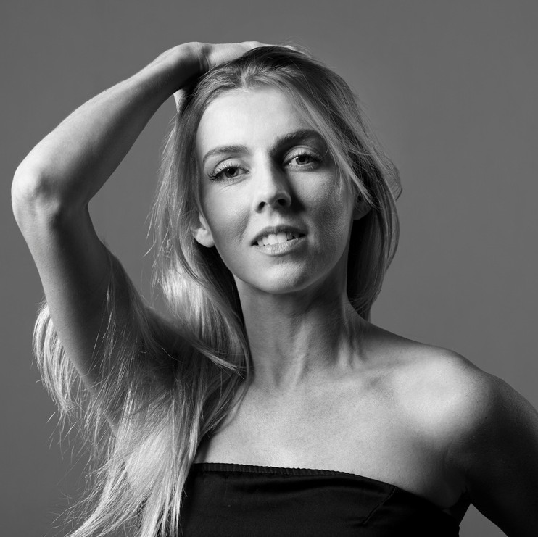
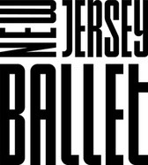
CATHERINE WHITING

APPRENTICES

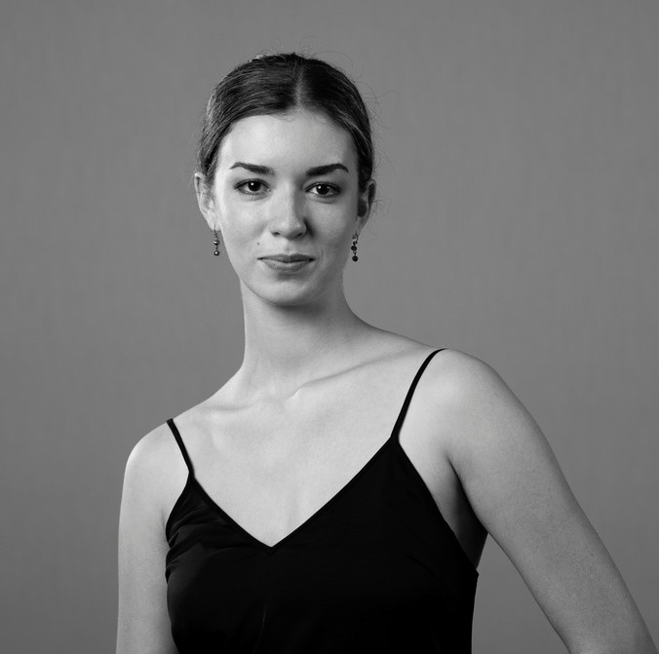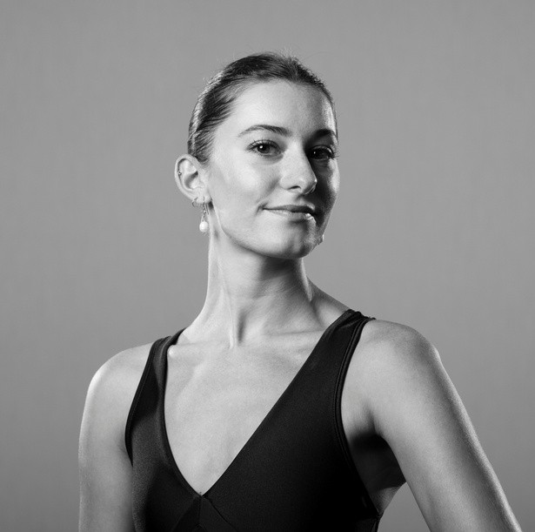

LILLI ETHEREDGE
ALEXANDRA LIMEBURG
Photo credit: Irina Leoni

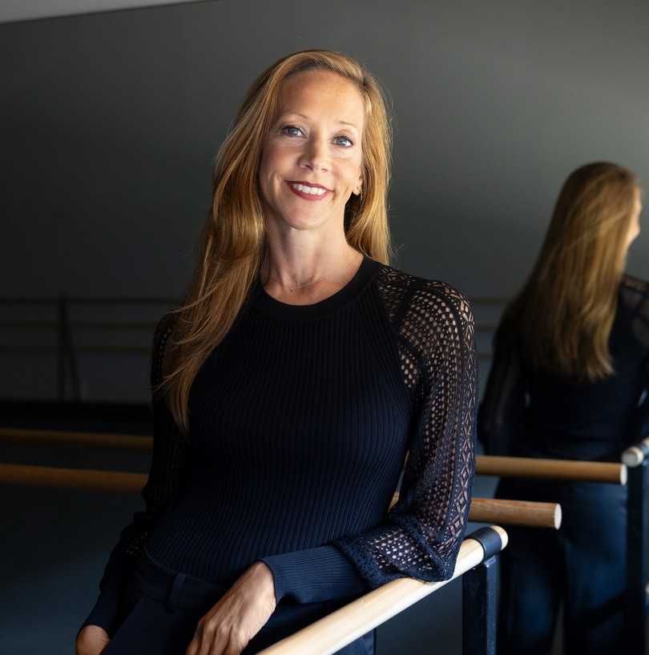
MARIA KOWROSKI was born in Grand Rapids, Michigan, where she began her ballet training at age seven with the School of Grand Rapids Ballet. Ms. Kowroski entered the School of American Ballet (SAB), the official school of New York City Ballet, in the fall of 1992. She became an apprentice with New York City Ballet in the summer of 1994 and was invited to join the Company as a member of the corps de ballet in January of 1995. In the spring of 1997, Ms. Kowroski was promoted to the rank of soloist and in the spring of 1999, she was promoted to principal dancer.
Ms. Kowroski has danced many principal roles in the Balanchine repertory including, Agon, Apollo, Concerto Barocco, Mozartiana, Diamonds, Rubies and Emeralds from Jewels, Prodigal Son, Stravinsky Violin Concerto, Chaconne and Bugaku. Ms. Kowroski has had the pleasure of being created on by several choreographers including Jerome Robbins, Christopher Wheeldon, Mauro Bigonzetti, Justin Peck, Peter Martins, Boris Eifman, and Helgi Tomasson. She has also had the great privilege of working with the great choreographers Alexei Ratmansky and William Forsythe. Ms. Kowroski was a guest artist with the Mariinsky ballet performing Swan Lake in 2003, a mixed Balanchine program in 2006 and 2019. In 1994 Ms. Kowroski was the recipient of the Princess Grace Award and in 2011 she received the Jerome Robbins award.
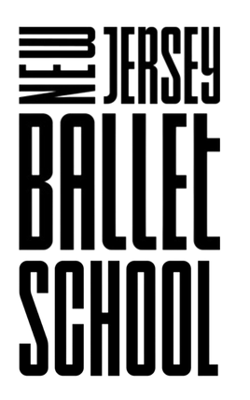
Ms. Kowroski became Acting Artistic Director of New Jersey Ballet in November 2021 and Artistic Director in September 2022. Under Ms. Koworski's directorship, a new work was commissioned and choreographed by former New York City Ballet principal dancer Harrison Ball with costumes by fashion designer Zac Posen. Most recently Ms. Kowroski won an Emmy as Creative Director for New Jersey Ballet's 2022 marketing video.
New Jersey Ballet School is
the Official School of New Jersey Ballet

- Open Classes for ages 4 thru adult •
- Summer Session July 29 - August 23, 2024 •

www.njschoolofballet.com

JUSTIN PECK is a Tony Award winning choreographer, director, filmmaker, and dancer based in New York City.
He is currently the acting Resident Choreographer of New York City Ballet. Justin began choreographing in 2009 at the New York Choreographic Institute. In 2014, after the creation of his acclaimed ballet EVERYWHERE WE GO, he was appointed as Resident Choreographer of New York City Ballet. He is the second person in the institution’s history to hold this title.
After attending the School of American Ballet at Lincoln Center from 2003-2006, Justin was invited to join the New York City Ballet as a dancer in 2006. As a performer, Justin has danced a vast repertoire of works by George Balanchine, Jerome Robbins,
Alexei Ratmansky, Lynn Taylor-Corbett, Benjamin Millepied, Christopher Wheeldon, and many others. In 2013, Justin was promoted to the rank of Soloist, performing full-time through 2019 with the company.
Justin has created over 50 dance-works -- more than 20 for New York City Ballet. His works have been performed by Paris Opera Ballet, San Francisco Ballet, Australian Ballet, Dresden Semperoper Ballet, Hong Kong Ballet, Boston Ballet, Juilliard, National Ballet of Canada, Miami City Ballet, Pacific Northwest Ballet, LA Dance Project, Dutch National Ballet, the School of American Ballet, Joffrey Ballet, Houston Ballet, Pennsylvania Ballet, Ballet Austin, Atlanta Ballet, Ballet Bordeaux, Finnish National Ballet, Ballet MET, Royal Danish Ballet, Cincinnati Ballet, University of Southern California (USC), and Ballet Arizona.
Working on a wide array of projects, Justin’s collaborators include composers Sufjan Stevens, The National, Bryce Dessner, Nico Muhly, Dan Deacon, Caroline Shaw, Chris Thile, Stephen Sondheim, M83, Dolly Parton; visual artists Shepard Fairey, Marcel Dzama, Shantell Martin, John Baldessari, Jeffrey Gibson, George Condo, Steve Powers, Jules de Balincourt; fashion designers Raf Simons, Mary Katrantzou, Humberto Leon (Kenzo, Opening Ceremony), Tsumori Chisato, Dries Van Noten; and filmmakers Steven Spielberg, Sofia Coppola, Damien Chazelle, Elisabeth Moss, Frances Lawrence, Bradley Cooper, and Jody Lee Lipes.
In 2014, Justin was the subject of the documentary BALLET 422, which presents Justin’s craft and creative process as a choreographer in great detail, as he creates New York City Ballet’s 422nd commissioned dance.
Justin has worked extensively as a filmmaker. In particular, his focus has been exploring new innovative ways of presenting dance on film. Peck choreographed the feature films RED SPARROW (2016) starring Jennifer Lawrence and directed by Francis Lawrence; WEST SIDE STORY (2021) in collaboration with director Steven Spielberg; and MAESTRO (2022) in collaboration with director/actor/writer Bradley Cooper. Peck's work as a director- choreographer for music videos include: THE DARK SIDE OF THE GYM (2017) for The National; THANK YOU, NEW YORK (2020) for Chris Thile; and THE TIMES ARE RACING (2017)
for Dan Deacon. In 2018, Justin directed the New York Times GREAT PERFORMERS Series (starring Julia Roberts, Ethan Hawke, Lakeith Stanfield, Glenn Close, Toni Collette, Yoo Ah-in, Emma Stone, Olivia Colman, Regina Hall, Yalitzia Aparicio, Elsie Fischer, and Rachel Weisz).
Justin choreographed the 2018 BROADWAY revival of CAROUSEL. The production was directed by Jack O'Brien and starred Jessie Meuller, Joshua Henry, & Renée Fleming.
Justin’s honors include: the National Arts Award (2018), the Golden Plate Honor from the Academy of Achievement (2019), the Bessie Award for his ballet RODEO: FOUR DANCE EPISODES (2015), the Gross Family Prize for his ballet EVERYWHERE WE GO (2014), the World Choreography Award for WEST SIDE STORY (2022), and the Tony Award for his work on Broadway’s CAROUSEL (2018).

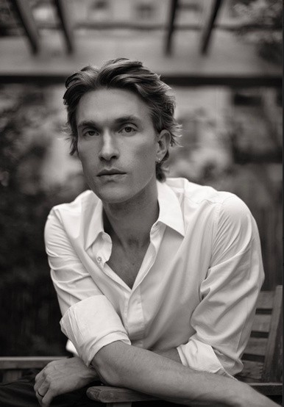
HARRISON BALL was born in Houston, Texas and began his dance training at the age of four at The Charleston Ballet Theatre in South Carolina. Mr. Ball began studying at the School of American Ballet, the official school of New York City Ballet (NYCB), as a full-time student in the fall of 2007. In June of 2011, he became an apprentice with NYCB, and in July of 2012, he joined NYCB as a member of the corps de ballet. Mr. Ball was promoted to soloist in February 2017 and later to principal in 2022. In April 2023, Mr. Ball retired from New York City Ballet. During his tenure at New York City Ballet, Mr. Ball performed featured roles in ballets by George Balanchine, Peter Martins, Kyle Abraham, Jerome Robbins, William Forsythe, Justin Peck, Mauro Bigonzetti, and many others. Mr. Ball is the recipient of the Mae. L Wein Award and the Janice Levin Award. ‘Purcell Suite’ was Mr. Ball’s first
choreographic commission. Mr. Ball resides between San Francisco and New York City and is pursuing careers in acting and choreography.

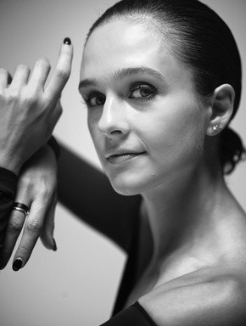
Lauren Lovette personifies the intertwining of dance and choreography, moving seamlessly from one to the other. Her work has been commissioned and performed by leading dance companies and festivals, including the New York City Ballet, American Ballet Theatre, the Vail International Dance Festival, American Ballet Theatre Studio Company, the Paul Taylor Dance Company, Nevada Ballet Theatre, as well as a self-produced evening entirely of her own work in which she also danced, Why It Matters.

Born in Thousand Oaks, California, Lovette began studying ballet at the age of 11 at the Cary Ballet Conservatory in Cary, North Carolina. She enrolled at SAB as a full scholarship student in 2006.
In October 2009, Ms. Lovette became an apprentice with NYCB and joined the Company as a member of the corps de ballet in September 2010. Promoted to soloist in February 2013 and to principal dancer in June 2015, she stepped down from her position at the company in 2021 in order to embark on a career devoted to dance and choreography in more equal measure. She is now the choreographer in residence at the Paul Taylor Dance Company and performs as a guest principal dancer around the world.
Ms. Lovette received the Clive Barnes Award for dance in December 2012 and was the 2012- 2013 recipient of the Janice Levin Award.
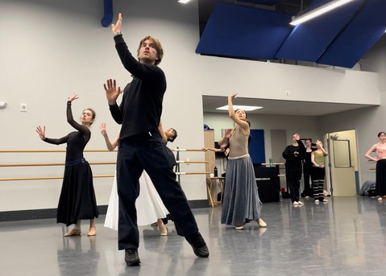
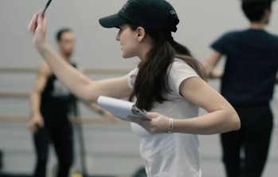

ZAC POSEN is an internationally acclaimed fashion designer and cookbook author who appeared as a judge on six seasons of the Emmy-nominated Project Runway. He is the Executive Vice President, Creative Director at large of GAP Inc., and Chief Creative Officer of Old Navy. Posen launched his eponymous collection in 2001 with a vision for modern American glamour that married couture technique with striking innovation. Raised in New York, Zac began his design training early. He attended London’s Central Saint Martin's University in the womenswear program. In 2004, he was awarded one of fashion’s most prestigious honors, Swarovski’s the Perry Ellis Award for Womenswear by the CFDA. In 2015, Zac Posen was also awarded Designer of the Year by Women’s Wear Daily and Variety Magazine.Zac is known globally for his technique in artisanal craftsmanship, anatomical construction and textile manipulation.
His daywear, suiting and red-carpet evening wear are infused with his bold sophistication, sexy femininity and distinctive glamour.
Over the years, his designs have been worn by leading women, including Uma Thurman, Natalie Portman Oprah, First Lady Michelle Obama, Gwyneth Paltrow, Naomi Watts, Claire Danes and Rihanna.For the 2021 Met Gala, Posen designed a custom gown for American icon Debbie Harry featuring a hoop skirt overlaid with silk swirls in red and white echoing the furling stripes of the U.S. flag. and a denim jacket that he repurposed from his own jeans. He additionally created a custom look for Paloma Elsesser.
Posen showcased his 3D collection of gowns for the 2019 Met Gala, dressing Jourdan Dunn, Nina Dobrev, Katie Holmes, Deepika Padukone and Julia Garner. Posen served as a costume designer on THE OUTFIT, a gripping and masterful thriller from the Academy Award-winning writer of THE IMITATION GAME (Graham Moore), which premiered in theaters in March 2022. He both appeared in Warner Bros' Ocean's Eight and designed exclusive pieces for the film, as well as for the blockbusters Sex and the City 1 and 2.
Posen, a lover of food and an inventive chef, gained an enormous following on Instagram where he showcases his cooking with the hashtag, #cookingwithzac, which led him to create his first cookbook Cooking With Zac, published by Rodale in October 2017. His recipes have been featured in Food & Wine, Vogue.com, On the Table with Eric Ripert, Good Morning America, The Martha Stewart Show and The Chew. The documentary, House of Z, chronicling Posen’s career, premiered at the 2017 TriBeCa Film Festival to critical acclaim. Along with his consistent support of St. Jude’s, the LGBTQIA community, and City Harvest, amongst others, Zac Posen also is an Ambassador for The Elizabeth Taylor AIDS Foundation and CARE.
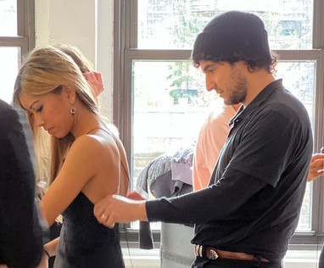
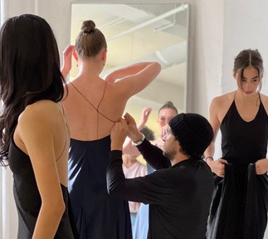

Murder Ballades
Choreography by Justin Peck Staged by Charles Hodges Costumes Designed by Justin Peck
Original Lighting Design by Brandon Stirling Baker Visual Design: Sterling Ruby
Lighting Adapted by Jesse Campbell and Lauren Libretti

Murder Ballades was originally commissioned by L.A. Dance Project – World Premiere, 2013.
Murder Ballades Composed by Bryce Dessner
Presented under license by G. Schirmer, Inc., o/b/o Chester Music Ltd. , copyright owners.

Ilse Kapteyn Catherine Whiting Emily Barrows
Felipe Valentini David Lopena Vinicius Freire

INTERMISSION

Purcell Suite
Choreography by Harrison Ball Music by Henry Purcell Costume Design by Zac Posen Lighting by Jesse Campbell

Emily Barrows, Lilli Etheredge, Yuiko Honda, Se Hyun Jin, Ilse Kapteyn, Raleigh Ledford,
Alexandra Limeburg, Risa Mochizuki, Denise Parungao, Abigail Robison, Eunice Suba, Catherine Whiting

Dido and Aeneas/Act I - Overture
Lilli Etheredge, Se Hyun Jin, Ilse Kapteyn, Raleigh Ledford Denise Parungao, Abigail Robison, Eunice Suba

Dido and Aeneas/Act II - Glitter Ground - A Dance Lilli Etheredge, Se Hyun Jin, Ilse Kapteyn, Raleigh Ledford Denise Parungao, Abigail Robison, Eunice Suba

Dido and Aeneas/Act II - Glitter Ground - A Dance
Lilli Etheredge, Se Hyun Jin, Ilse Kapteyn, Raleigh Ledford Denise Parungao, Abigail Robison, Eunice Suba

Distress’d Innocence, Z. 577: III.
Emily Barrows, Yuiko Honda, Alexandra Limeburg Risa Mochizuki, Catherine Whiting

Distress’d Innocence, Z. 577: IV.Air
Ensemble

Bonduca, Z. 574: II. Air I
Ensemble

Dido and Aeneas/ Act 2 - Ritornelle Thanks to these lonesome vales
Ensemble

Timon of Athens, Z.632 / The Masque Curtain Tune On A Ground
Ensemble

Dido and Aeneas, Z. 626: Act III:
When I am Laid on Earth (Sung by Leontyne Price)
Ensemble

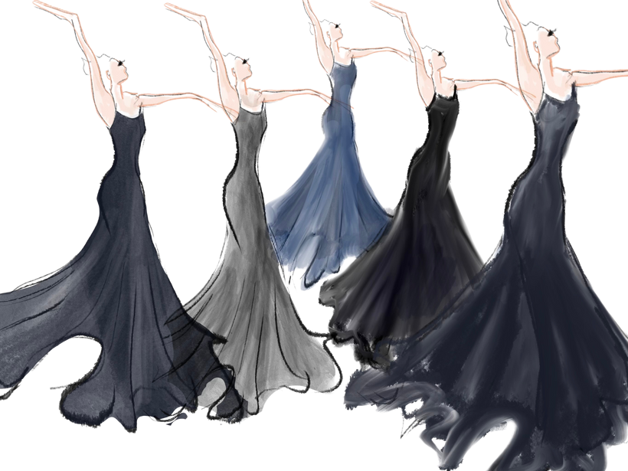
by Zac Posen

INTERMISSION

World Premiere
Jewel Box
Choreography by Lauren Lovette Music Concerto for Orchestra Composed by Kevin Puts Costumes by Libby Stadstad
Design Consultant by Libby Stadstad Set Design by SHOWFAB Lighting by Lauren Libretti

Concerto for Orchestra
By arrangement with Boosey and Hawkes, Inc., o/b/o G. Ricordi & Co. New York.
Recorded by: St. Louis Symphony Orchestra

Emily Barrows, Louis De Felice, Vinicius Freire, Yuiko Honda, Akira Iida, Se Hyun Jin, Raleigh Ledford, David Lopena,
Risa Mochizuki, Denise Parungao, Jonathan Philbert, Brian Sevilla, Joshuan Vazquez, Catherine Whiting

Drum
Ensemble

Comb
Akira Iida, Vinicius Freire, Jonathan Philbert, Brian Sevilla

Ballerina
Se Hyun Jin
Louis DeFelice, David Lopena, Jonathan Philbert

Flywheel
David Lopena
Emily Barrows, Yuiko Honda, Raleigh Ledford, Catherine Whiting

Winding Key
Denise Parungao, Joshuan Vazquez

Spring Housing
Ensemble

The world premiere of Jewel Box is generously supported by:

Charles and Debbi Adelman Paul Cabral
Susan Campbell Stuart and Meryl Coleman Leslie and Richard Curtis John and Malo Harrison
Eric Lee Jonna Mackin NJPAC

As of April 8, 2024

New Jersey Ballet Board of Directors

Scott T. Tross, Esq.
Chairman
Susan A. Manardo, Esq.
Vice Chair

Tom Loucopolos
Treasurer
Scott Becchi
President

Jason Dailey
Vice President

Jennifer Bakshi
Secretary

Nicole Blomfield Bea Daggett Ellen Dec
Susan Head PJ Hilbert
Michael Kurze Gale DiFabio Raffield
Donald A. Robinson, Esq.
Liza M. Walsh, Esq.
Geoffrey Weinman, Ph. D.

Honorary Board of Directors
The Honorable Thomas H. Kean

Ruthi Zinn Byrne Michael K. Furey, Esq.
Lawrence P. Goldman Millie E. Williams, Esq.

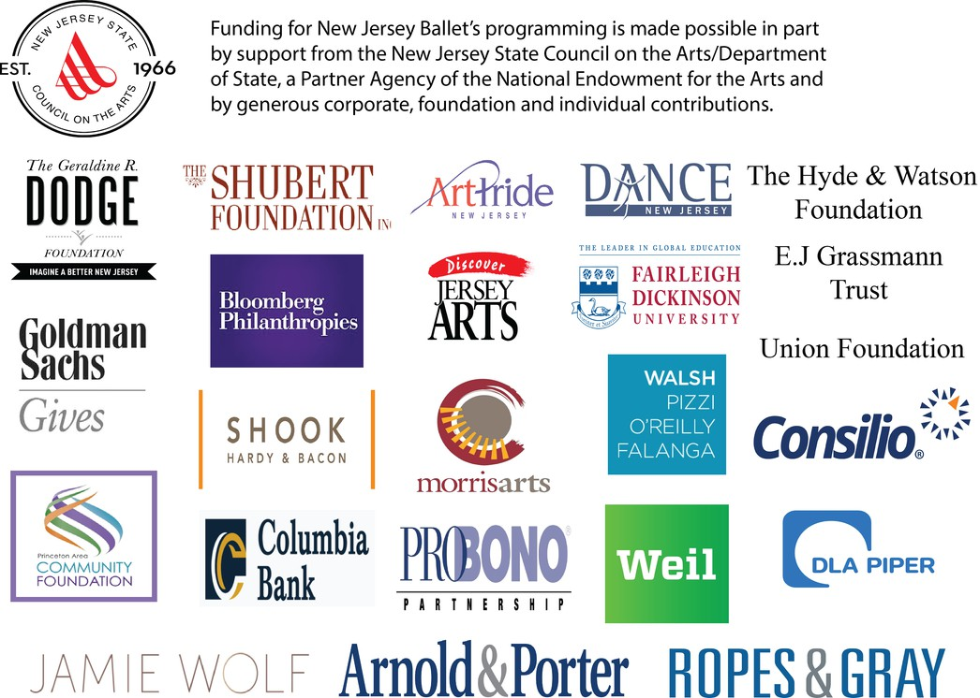
The theatres where NJB performs meet ADA requirements. Program information and/or program notes on audio cassette are available from NJB prior to performances upon request.
Call 973-597-9600. Large print programs are available at performances.

THANK YOU TO OUR LEAD SUPPORTERS

New Jersey State Council on the Arts State of New Jersey
Scott & Evangeline Tross Millie E. Williams
The Shubert Foundation Scott & Donya Bommer Lynn McMahon
John & Barbara Vogelstein Scott & Rosemary Becchi
The Hyde & Watson Foundation Achelis & Bodman Foundation The Kosloski Family Foundation Union Foundation
E.J. Grassmann Trust John & Kristin Kennedy Clark Columbia Bank Foundation Walsh Pizzi O'Reilly Falanga
Arnold & Porter, LLP Weil Gotshal Manges, LLP
Ropes & Gray, LLP Shook Hardy Bacon, LLP DLA Piper
Liza M. Walsh Susan Head
Paul Cabral Leslie & Richard Curtis
Charles and Debbi Adelman Susan Campbell
Stuart and Meryl Coleman John and Malo Harrison Eric Lee
Jonna Mackin Schumann Fund Ryan Kinkade Jennifer Bakshi Nicole Blomfield Walter & Ellen Dec PJ Hilbert
Bloomberg Philanthropy Donald A. Robinson Thomas & Gale Raffield George A. Ohl, Jr. Trust Susan A. Manardo Michael Kurze
Jason Dailey Tom Loucopolos
Geoffrey Weinman, Ph.D.

WELLNESS SPONSORS

www.professionalpt.com
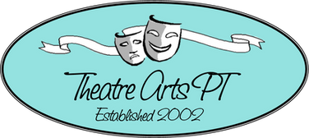
www.theatreartspt.com

www.tri-countyortho.com

www.bbhmassage.com

7-9 Vreeland Rd, Florham Park, NJ 07932 info@njballet.org | 973-597-9600 www.njballet.org

